Title | Creating and Manipulating Arrays Using NumPy
Problem Statement | Create a 2D array of shape (3, 4) with random integers between 0 and 10. Perform the following operations: calculate the mean and standard deviation of the entire array, slice the array to get the first two rows and last two columns, reshape the array to shape (4, 3), and perform element-wise multiplication with another array of the same shape
Objectives | • To create and manipulate two-dimensional NumPy arrays.  • To represent predefined array values using a Python dictionary.  • To calculate the mean and standard deviation of the entire array.  • To slice the array and extract selected rows and columns.  • To reshape an array from shape (3, 4) to shape (4, 3).  • To perform element-wise multiplication between arrays of the same shape.  • To understand array shape, slicing, reshaping and numerical operations using NumPy.
Dataset  URL Link /  File | Predefined dictionary dataset used directly inside the Python program:  Array Row 1 Row 2 Row 3 Row 4  Array1 (3 x 4) 2, 5, 7, 1 8, 3, 6, 4 9, 0, 5, 2 —  Array2 (4 x 3) 1, 2, 3 4, 5, 6 7, 8, 9 2, 3, 4  No external dataset file or URL is required.
Functions  Details | Sl. No. | Function | Package | Description of function
 | 1 | np.array() | NumPy | Converts dictionary values into NumPy arrays.
 | 2 | shape | NumPy | Returns the dimensions of an array as rows and columns.
 | 3 | np.mean() | NumPy | Calculates the mean of all elements in the array.
 | 4 | np.std() | NumPy | Calculates the standard deviation of all array elements.
 | 5 | Array slicing | NumPy | Extracts the first two rows and last two columns.
 | 6 | reshape() | NumPy | Changes the array shape from (3, 4) to (4, 3).
 | 7 | round() | Python | Rounds numerical output to the specified decimal places.
 | 8 | print() | Python | Displays arrays, calculations and headings in the console.
 | 9 | range() | Python | Creates a sequence of integer values when required.
 | 10 | len() | Python | Returns the number of items in an object.
 | 11 | dtype | NumPy | Shows the data type of array elements.
 | 12 | Element-wise * | NumPy | Multiplies corresponding elements of equal-shaped arrays.
Steps/  Process/  Procedure/  Algorithm/  Flowchart/  Model | Step 1: Import NumPy using import numpy as np.  Step 2: Create a predefined dictionary containing Array1 and Array2.  Step 3: Convert the dictionary values into NumPy arrays using np.array().  Step 4: Display Array1 and verify its shape as (3, 4).  Step 5: Calculate the mean using np.mean().  Step 6: Calculate the standard deviation using np.std().  Step 7: Slice Array1 using array1[:2, -2:] to get the first two rows and last two columns.  Step 8: Reshape Array1 to (4, 3) using reshape(4, 3).  Step 9: Display Array2 and verify its shape as (4, 3).  Step 10: Perform element-wise multiplication using reshaped_array * array2.  Step 11: Display all results and their respective shapes.  Step 12: Verify that all requested NumPy operations are completed successfully.
Program | import numpy as np  array_data = {  "Array1": [[2, 5, 7, 1],  [8, 3, 6, 4],  [9, 0, 5, 2]],  "Array2": [[1, 2, 3],  [4, 5, 6],  [7, 8, 9],  [2, 3, 4]]  }  array1 = np.array(array_data["Array1"])  array2 = np.array(array_data["Array2"])  print("ORIGINAL 2D ARRAY")  print(array1)  print("Shape:", array1.shape)  mean_value = np.mean(array1)  standard_deviation = np.std(array1)  print("\nMean:", round(mean_value, 2))  print("Standard Deviation:", round(standard_deviation, 2))  sliced_array = array1[:2, -2:]  print("\nFIRST TWO ROWS AND LAST TWO COLUMNS")  print(sliced_array)  print("Shape:", sliced_array.shape)  reshaped_array = array1.reshape(4, 3)  print("\nRESHAPED ARRAY")  print(reshaped_array)  print("Shape:", reshaped_array.shape)  print("\nSECOND ARRAY")  print(array2)  multiplied_array = reshaped_array * array2  print("\nELEMENT-WISE MULTIPLICATION")  print(multiplied_array)  print("Shape:", multiplied_array.shape)  print("\nFINAL SUMMARY")  print("Original Shape:", array1.shape)  print("Mean:", round(mean_value, 2))  print("Standard Deviation:", round(standard_deviation, 2))  print("Sliced Shape:", sliced_array.shape)  print("Reshaped Shape:", reshaped_array.shape)  print("Multiplied Shape:", multiplied_array.shape)
Output Snapshots  With  Explanation/  Observations | Screenshot 1: Original Array and Shape  Figure 1.1 Original 2D Array  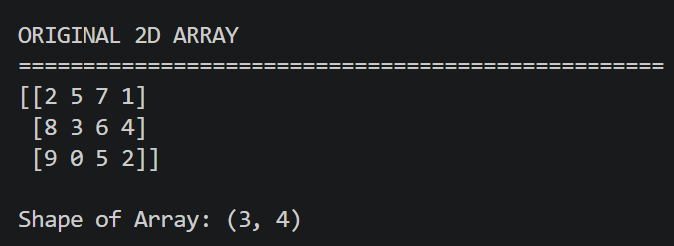  The predefined dictionary values were converted into a NumPy array. The output confirms that the array contains 3 rows and 4 columns.  Screenshot 2: Mean and Standard Deviation  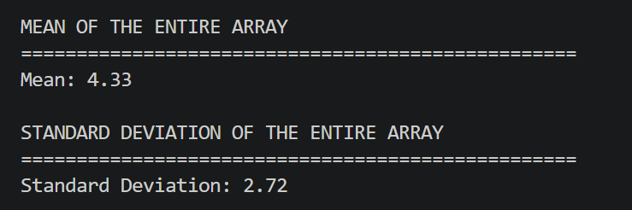  The mean represents the average of all elements in the array, while the standard deviation shows how widely the values are distributed around the mean.  Figure 1.2 Mean & Standard Deviation of the Array  Screenshot 3: Array Slicing  Figure 1.3 Sliced Array  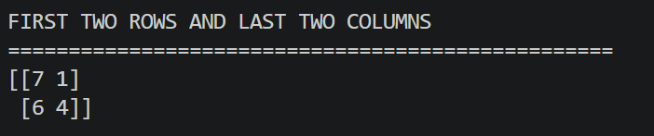  Array slicing was performed using array1[:2, -2:]. The resulting sliced array has a shape of 2 × 2.  Screenshot 4: Reshaped Array  Figure 1.4 Reshaped Array  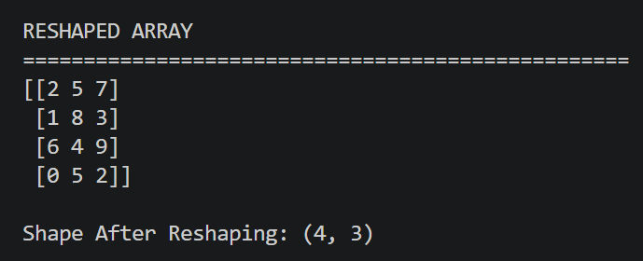  The reshape() function changed the arrangement of the 12 elements without changing their values or total count.  Screenshot 5: Element-wise Multiplication  Figure 1.5 Element Wise Multiplication  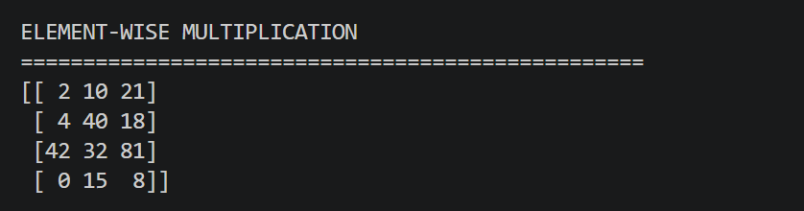  Corresponding elements of the two arrays with shape (4, 3) were multiplied using the * operator.  Screenshot 6: Final Summary  Figure 1.6 Final Summary  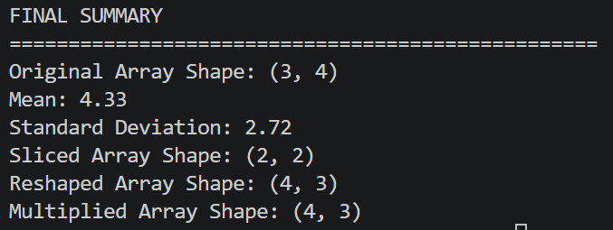  The final output verifies that all statistical, slicing, reshaping and multiplication operations were completed successfully.
Conclusions | The NumPy array manipulation exercise was completed successfully. A two-dimensional array of shape (3, 4) was created using predefined dictionary data. The mean and standard deviation were calculated, the first two rows and last two columns were extracted through slicing, and the array was reshaped to (4, 3). Element-wise multiplication was performed with another array of the same shape. The exercise provided practical understanding of NumPy array creation, statistical calculations, slicing, reshaping and element-wise operations.
References | 1. Michael Freeman and Joel Ross, Programming Skills for Data Science: Start Writing Code to Wrangle, Analyze, and Visualize Data with R, Addison-Wesley, 2018.  2. NumPy documentation for array creation, statistics, slicing, reshaping and mathematical operations.  3. Python program link (https://github.com/hasnainmakada-99/Data-Science-Codes/blob/main/WEEK%203/PRACTICE_PROGRAM.py)  4. Programming for Data Science (MACSE502) class lecture notes.

